EVALUATING CLINICAL PRACTICE FORMS

- Log on to www.taskstream.com using your personal username and password.

- Make sure you are in the “Evaluator” tab:

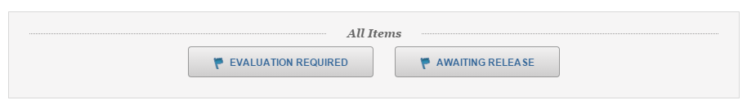
- Select “Evaluation Required”:

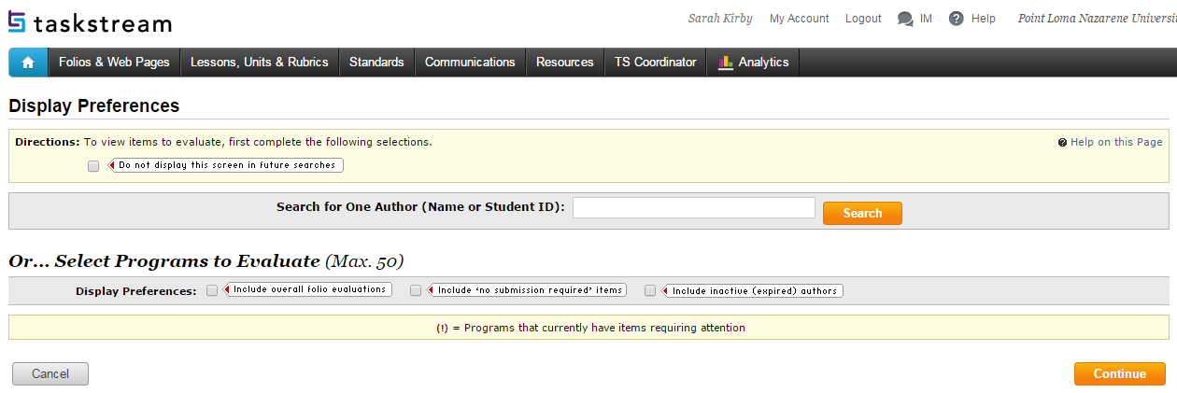
- Type the name of your Teacher Candidate and select “Search”:

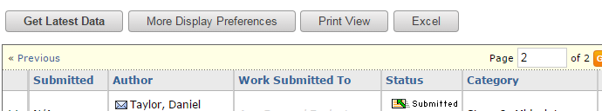
- Click “Work Submitted To” to sort by this category:

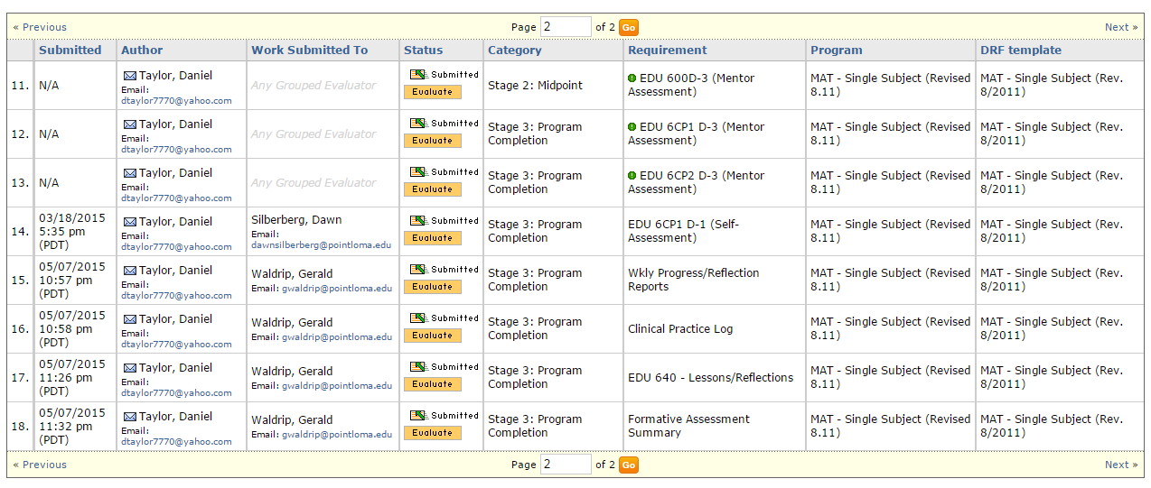
- If necessary, click through the pages until you see work submitted to you:

- All like items should be submitted together in the correct category. Documents should be submitted in the following categories:

  - EDU [course number] – Lessons/Reflections: All Formal Lesson Plans AND all Analysis and Reflection Conference Guides

  - Clinical Practice Log: The Clinical Practice log with all weeks recorded

  - Daily Lesson Plan: All Daily Lesson Plans

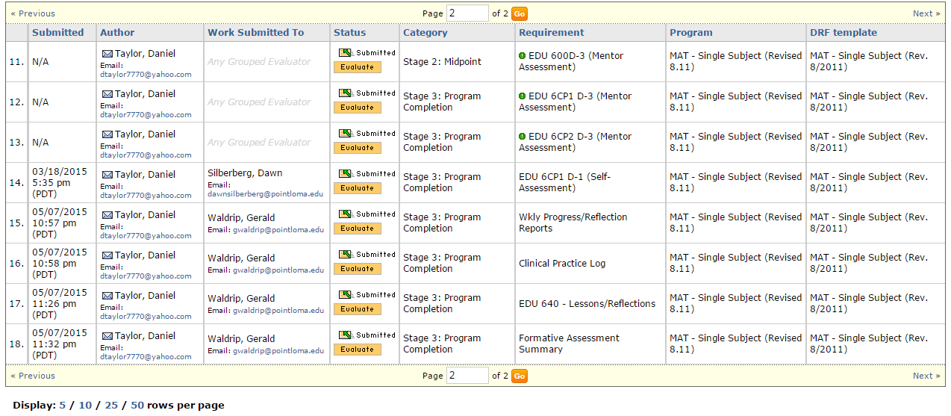
  - Wkly Progress/Reflection Reports: All Weekly Progress and Reflection Reports
e. Formative Assessment Summary: All Formative Assessment Summary forms (and, for Single Subject
candidates, the Single Subject Competency Assessment)

- To evaluate documents:

  - Select “Evaluate” next to the first category you would like to evaluate:
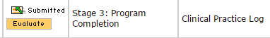

  - Click the attachment to view:
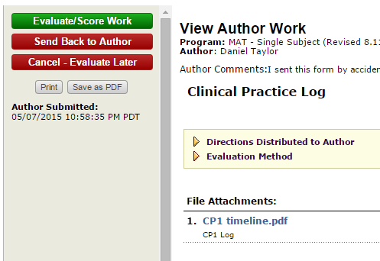

  - If all necessary documents are submitted and in the right slot:

    - Select “Evaluate/Score Work”:
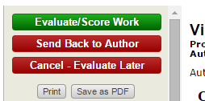

    - Select “Meets Requirement”, “Record as final and release evaluation to author now”, and “Submit Evaluation Now”:
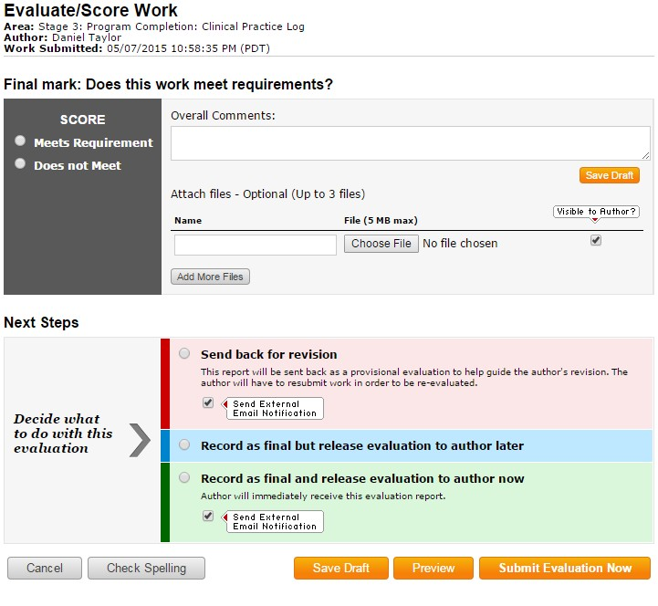

  - If a document is missing or submitted in the wrong slot:

    - Select “Send Back to Author”:

    - Explain the error in the comments box and select “Send Back to Author Now”:
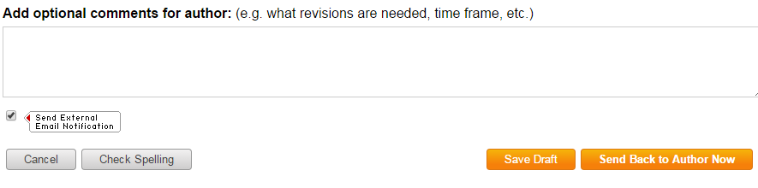

- Repeat steps 8a – 8d for the remaining categories.

- Once all documents have been submitted and evaluated, assign the teacher candidate a grade in the PLNU portal.

